NOTERs (Notice to SeaReyers) 06.07.2010
Factory Fly in at Lake Idamere
On June 26, 2010 Progressive Aerodyne will host an open house at the new factory location on Lake Idamere, Tavares, Florida. SeaReys are welcome to fly in and use the new ramp for the occasion. Some general information, subject to PIC verification, is provided below.
Location:
GPS Coordinates: Lake Idamere is located at: 28° 46’ 00.24” N, 81° 44 47.64W (center of lake, elevation is 66’).
From Leesburg airport (KLEE): it is 5.28 sm (4.58 nm) at 136.49° from KLEE.
From the Tavares Seaplane Base: it is 2.69 sm (2.33 nm) at 209.91° from the seaplane base.
Tavares Seaplane Base is located at 28° 48’ 02.00” N, 81° 43’ 39.56” W (elevation 63’).
The factory building is located on the west edge of the lake and is accessed by means of a concrete ramp.
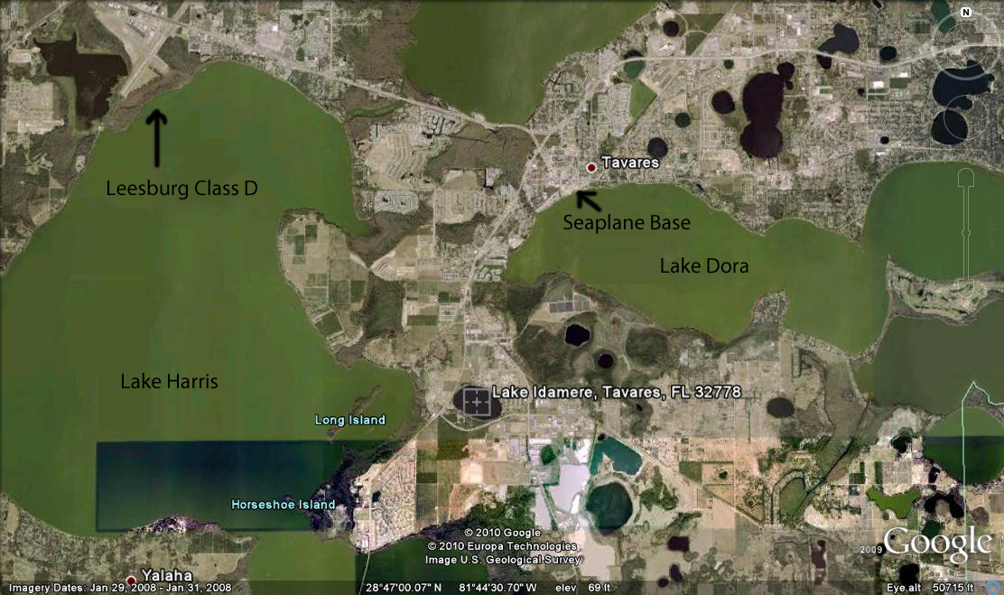
Lake Dimensions, Topography, Obstructions and Airspace
Lake Idamere is about 2,866’ long at its maximum length (NW to SE, 115°), 1750’ wide (NE to SW, 214 degrees across lake center). The lake elevation is 66’. Elevations to the west are generally up to 135’, south is 86’, east is 80’ to 90’ and north is up to 100’. A landfill is located ½ mile to the south and east (top elevation of 104’). Unlike most of Florida’s lakes, the higher terrain to the west may require a steeper approach to maintain adequate clearance.
There are also obstructions in the near vicinity (church steeple, fire tower). A power line follows the road (S.R. 19) on the western side of the lake. The closest towers are listed on the current sectional at 342’, 379’ and 491’. A cell tower is located north of the lake.
Leesburg (KLEE) Class D airspace (SFC to 1600’) is approximately is approximately 1 mile west of the western edge of the lake. The neighborhood to the east of the lake is a noise sensitive area (do not overfly). There is a hospice and church directly west of the factory (do not overfly). Most of the southern shore of the lake is a county park.
Boats will likely be present on the lake. It is possible that the Lake County Sheriff will have a safety boat on the lake. The county park also has a boat ramp and the lake is used by locals for fishing and skiing. Avoid boat traffic.
Preferred Approaches
Winds in the area typically favor an east or west approach. To avoid sensitive areas and obstructions, factory aircraft typically fly a pattern for either a 14 or 32 landing lane. When landing to the southeast, the preferred approach is over empty fields. Departure is over the landfill to the southeast. Landing to the northwest follows a reverse approach.
Do not fly low over houses on the northern shore or the hospice to the west of the lake. Plan a pattern that provides maximum clearance over people, vehicles, vessels or structures, consistent with adequate length for landing. Use caution for power lines along the roadway.
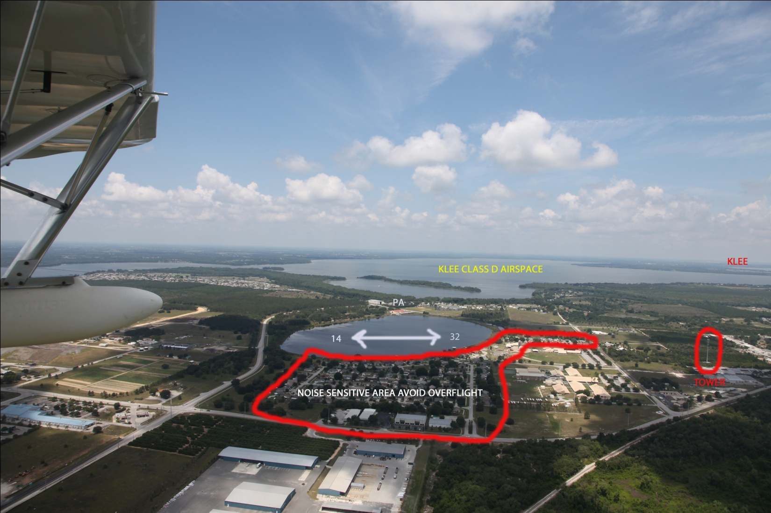

Radio Communication
Common advisories may be broadcast on 123.375 for local airborne advisories. An air boss (Russ Garner) will be on the frequency primarily to sequence aircraft using the ramp and parking area. Movement within the ramp area will be directed by Joe Becker on frequency 123.45. All aircraft are responsible for their own collision avoidance.

Leesburg Class D tower may be contacted on 119.75 (0700 to 1900 local). The facility does not have radar service, so position announcement is important. The airport has a WX AWOS available on 134.325 (or by phone: 352-787-1565).
Tavares Seaplane Base uses 122.75 as a local advisory frequency. It is monitored for assistance in parking or fueling.
Summary of Frequencies
Lake Idamere Advisories: 123.375
PA Ramp Advisories: 123.45
Tavares SPB: 122.75
Leesburg Tower: 119.75
Leesburg Awos: 134.325
Orlando North Airpark (FA83): 122.8 (Note: Right Hand Patter for Rwy 9)
Bob White Field (X61): 122.8
Orlando Apopka (X04): 123.05
Overflow Staging
In the event that airspace becomes too congested, pilots may be requested to stage over Lake Harris, south of Leesburg Class D airspace (south of the Highway 19 Bridge). The large lake south of the bridge is Little Lake Harris. Pilots should avoid over flight of subdivision on the north side at the bridge, and Howey in the Hills, a town on the west side of Little Lake Harris.
If long delays are anticipated, pilots may be advised to land and contact the air boss by cell phone (863-559-3216) prior to re-entry. Pilots may chose to land at the seaplane base or other nearby lake or airport.
Parking, Maintenance
After landing it is important to quickly exit the landing lane and taxi directly to the ramp. Parking on the ramp is available at the site for up to thirty SeaReys. Follow instructions from the air boss to access the ramp. On the apron, follow the directions of ramp boss for parking. Overflow parking will be at the Tavares Seaplane Base.
In the event of gear problems, a beach area is available adjacent to the large boat lift north of the ramp. Please reserve this area for
For More Information
Contact Progressive Aerodyne at 352-253-0108.
Russ Garner Cell Phone: 863-559-3216
Kerry Richter Cell Phone: 407-375-1220

